**ABSTRACT**

The IoT firefighting robot, developed using Arduino Uno R3, integrates cutting-edge features aimed at enhancing fire detection and suppression capabilities. Equipped with a suite of sensors including smoke, LPG gas, flame, and ultrasonic, the robot serves as a crucial tool in safeguarding against fire emergencies. Central to its functionality is the utilization of a smoke sensor, enabling real-time detection of LPG gas, triggering immediate SMS alerts for swift response. Moreover, upon detecting a fire, the robot autonomously initiates a call, facilitating rapid intervention to mitigate potential hazards. The integration of ultrasonic technology further enhances its operational efficiency by ensuring precise navigation, enabling the robot to halt at an optimal distance from obstacles engulfed in flames. This feature not only enhances safety but also enables effective deployment of firefighting measures. Crucially, the robot employs a sophisticated flame sensor array, strategically positioned to detect flames from multiple directions. In response to left or right flame sensor activation, the robot executes precise maneuvers, swiftly altering its course to navigate away from danger. Moreover, upon detecting flames directly ahead, the robot advances forward, utilizing its integrated capabilities to assess and address the situation. In essence, the IoT firefighting robot represents a groundbreaking advancement in fire safety technology, leveraging Arduino Uno R3's versatility to deliver a comprehensive solution for early detection and intervention. By seamlessly integrating sensor data and autonomous functionality, the robot not only enhances response times but also mitigates risks associated with manual intervention. With its ability to adapt to diverse firefighting scenarios, the robot stands as a testament to innovation in safeguarding lives and property against the ever-present threat of fire emergencies.

**TABLE OF CONTENTS**

|  |  |  |
| --- | --- | --- |
| **CHAPTER NO.** | **TITLE** | **PAGE NO.** |
|  | **LIST OF FIGURES**  **LIST OF TABLES**  **LIST OF ACRONYMS** |  |
|  | **CHAPTER 1: INTRODUCTION**   * 1. BACKGROUND…………………………………………….   2. MOTIVATION……………………………………………   3. PROBLEM STATEMENT………………………………...   4. OBJECTIVE………………………………………………   5. SCOPE OF THE PROJECT…………………………………… | **11 - 13** |
| **2.** | **CHAPTER 2: LITERATURE SURVEY**  2.1 SUMMARY OF THE EXISTING WORK……….  2.2 CHALLENGES PENSENT IN THE EXISTING SYSTEM………… | **14 - 18** |
| **3.** | **CHAPTER 3: REQUIREMENT**  3.1 HARDWARE REQUIREMENT……………………………………...  3.2 SOFTWARE REQUIREMENT……………………………………  3.3 BUDGET……………………………………  3.4 GANTT CHART…………………………………… | **19 - 23** |
| **4.** | **CHAPTER 4: ANALYSIS AND DESIGN**  4.1 PROPOSED METHODOLOGY……………………………………...  4.2 SYSTEM ARCHITECTURE……………………………………  4.3 MODULE DESCRIPTIONS…………………………………… | **24 - 36** |
| **5.** | **CHAPTER 5: IMPLEMENTATION & TESTING**  5.1 DATA SET……………………………………...  5.2 SAMPLE CODE……………………………………  5.3 SAMPLE OUTPUT……………………………………  5.4 TEST PLAN & DATA VERIFICATION………………………… | **37 - 53** |
| **6.** | **CHAPTER 6: RESULTS**   * 1. RESEARCH FINDINGS…………………………………………..   6.2 RESULT ANALYSIS & EVALUATION METRICS……………… | **54 - 57** |
|  | CONCLUSIONS AND FUTURE WORK………………...  REFERENCES…………………………………………….. | **57 - 60** |

**LIST OF FIGURES**…………………………………………………………………13

3.4 GANTT CHART…………………………………………………………………2

4.2.1 FLOW CHART…………………………………………………………………1

4.2.2 STATE CHART DIAGRAM…………………………………………………..1

4.2.3 CIRCUIT DIAGRAM………………………………………………………….1

5.3 SAMPLE OUTPUT …………………………………………………………………8

**LIST OF TABLES**…………………………………………………………………3

2.1 LITERATURE SURVEY 1

3.3.1 HARDWARE COST…………………………………………………………1

5.4 TEST PLAN & DATA VERIFICATION………………………………………1

**CHAPTER 1**

**INTRODUCTION**

**1.1 BACKGROUND**

Traditional firefighting methods often face limitations in terms of response time and effectiveness, prompting the need for innovative solutions. The integration of Internet of Things (IoT) technology has revolutionized fire safety by enabling real-time monitoring and remote intervention. Arduino Uno R3, with its versatility and affordability, has emerged as a key platform for developing IoT-enabled firefighting systems. The IoT firefighting robot project aims to address these challenges by leveraging IoT technologies to enhance automation, communication, and safety in firefighting operations. Key challenges include sensor calibration, autonomous navigation, and GSM communication integration. Overall, the project represents a proactive step towards modernizing firefighting practices and minimizing the impact of fire incidents.

**1.2 MOTIVATION**

The motivation behind the IoT firefighting robot project arises from the shortcomings of traditional firefighting methods, such as delayed response times and limited communication capabilities. By harnessing IoT technology and Arduino Uno R3, the project seeks to revolutionize firefighting practices by introducing automation, real-time monitoring, and remote communication features. The ultimate goal is to enhance the effectiveness and efficiency of firefighting operations, minimize response times, mitigate risks, and save lives during fire emergencies. Additionally, the project aligns with broader efforts to embrace innovation and technology in addressing societal challenges, while offering opportunities for interdisciplinary collaboration and knowledge exchange. Overall, the project reflects a commitment to advancing fire safety standards through technological innovation and proactive risk management.

**1.3 PROBLEM STATEMENT**

1. Traditional firefighting methods suffer from limitations such as delayed response times and inadequate communication, leading to increased risks to life and property during fire emergencies.

2. Existing firefighting equipment lacks automation and real-time monitoring capabilities, hindering efficient firefighting operations, especially in complex or hazardous environments.

3. Manual intervention is often required for fire detection, navigation, and communication, which can be time-consuming and error-prone, compromising the effectiveness of firefighting efforts.

4. Current fire safety systems lack integration with modern technologies, such as Internet of Things (IoT), which could significantly enhance detection, prevention, and mitigation of fire incidents.

5. There is a need for a versatile and adaptable firefighting solution capable of autonomously detecting fires, navigating through obstacles, and communicating with stakeholders in real-time to minimize response times and mitigate risks effectively.

**1.4 OBJECTIVE**

1. Develop an IoT firefighting robot using Arduino Uno R3 capable of autonomously detecting fires, navigating through obstacles in real-time.

2. Integrate sensors such as smoke sensors, flame sensors, and ultrasonic sensors to enable the robot to perceive its surroundings accurately and make informed decisions during firefighting operations.

3. Implement automation features to enable the robot to respond swiftly to fire incidents, including sending SMS alerts upon detecting LPG gas and initiating phone calls in the event of fire detection.

4. Ensure precise navigation and obstacle avoidance by incorporating ultrasonic sensors to stop the robot at an optimal distance from obstacles in its path.

5. Develop algorithms for intelligent decision-making, including reactive strategies for maneuvering the robot left or right based on the location of detected flames, and forward movement upon detecting the center flame.

6. Validate the performance and functionality of the IoT firefighting robot through rigorous testing in simulated fire scenarios, ensuring reliability and effectiveness in real-world firefighting applications.

7. Facilitate interdisciplinary collaboration and knowledge exchange among experts in robotics, electronics, and fire safety engineering to leverage diverse expertise and perspectives in the development and refinement of the firefighting robot.

8. Document the design process, implementation details, and experimental results to contribute to the body of knowledge in the field of IoT-enabled firefighting systems and serve as a reference for future research and development endeavors.

**1.5 SCOPE OF THE PROJECT**

The scope of the project encompasses Develop an intelligent fire-fighting robot using Arduino, capable of autonomously navigating and extinguishing fires in controlled environments. Employ reliable flame sensors for accurate fire detection. In future, the proposed idea can be extended by using various sprinklers to put off the fire automatically based on the type of fire occurred. It can also be enhanced to send alerts to the user or owner of the place about the reason for the fire accident based on the gas from the fire using gas detectors. By implementing the above mentioned ideas the system becomes fully automated and the user also is alerted by the robot about the fire place by implementing GPS.

* Define project objectives clearly.
* Gather requirements comprehensively.
* Design system architecture.
* Develop or procure hardware components.
* Develop software components for control and monitoring.
* Integrate hardware and software for prototype.
* Conduct rigorous testing for performance validation.
* Ensure compliance with safety standards.

**CHAPTER 2**

**LITERATURE SURVEY**

**2.1 SUMMARY OF THE EXISTING WORK**

|  |  |  |  |  |  |
| --- | --- | --- | --- | --- | --- |
| **S.No** | **Topic** | **Author** | **Year** | **Advantage** | **Disadvantage** |
| 1 | IoT Based Intelligent Fire Fighting Machine Using Arduino | [Soundari D. V](https://ieeexplore-ieee-org.egateway.vit.ac.in/author/37088752770); [Shri Yazhini. R](https://ieeexplore-ieee-org.egateway.vit.ac.in/author/37089249894); [T Sneka](https://ieeexplore-ieee-org.egateway.vit.ac.in/author/37089252355); [S. Shobika](https://ieeexplore-ieee-org.egateway.vit.ac.in/author/37089850803); [Srijith Raj. S](https://ieeexplore-ieee-org.egateway.vit.ac.in/author/37088753215) | 2021 | Intelligent firefighting machines enhance safety by detecting fires, reducing risks for firefighters, and notifying owners promptly, while IoT-based fire extinguishing machines protect without endangering human lives. | Overreliance on technology may overlook human judgment and intervention, potentially leading to complacency or malfunction in critical situations. |
| 2 | IoT based Fire Fighting Robot | [Sabari L Uma Maheshwari](https://ieeexplore-ieee-org.egateway.vit.ac.in/author/37089592421); [R. Mohamed Atheeq](https://ieeexplore-ieee-org.egateway.vit.ac.in/author/37089592774); [U. Nikhil Surendar](https://ieeexplore-ieee-org.egateway.vit.ac.in/author/37085414641); [S. Navin Vaishnav](https://ieeexplore-ieee-org.egateway.vit.ac.in/author/37085390693) | 2022 | Robotics in firefighting reduces human risk in hazardous industrial settings, enhancing safety and efficiency through advanced technology and sensor integration, improving response time and minimizing fatalities. | Over-reliance on robotic firefighting may lead to reduced human oversight and decision-making, potentially overlooking nuances or unexpected challenges, risking effectiveness in complex emergency scenarios. |
| 3 | Application of NB-IoT in Intelligent Fire Protection System | [Tianxiang Li](https://ieeexplore-ieee-org.egateway.vit.ac.in/author/37087116158); [Ping Hou](https://ieeexplore-ieee-org.egateway.vit.ac.in/author/37087111486) | 2019 | NB-IoT technology in fire protection enhances firefighting capabilities, reducing loss of life and property by providing intelligent systems and IoT-based smoke-fire detection devices, improving response efficiency and accuracy. | Dependence on NB-IoT for fire protection may raise concerns about network reliability, potential vulnerabilities, and accessibility issues in remote or underdeveloped regions, impacting overall effectiveness. |
| 4 | Automatic Fire Fighting Robot using RPI | [R Sarath Kumar](https://ieeexplore-ieee-org.egateway.vit.ac.in/author/37089028484); [J Hariharan](https://ieeexplore-ieee-org.egateway.vit.ac.in/author/37089029339); [R S Revanth](https://ieeexplore-ieee-org.egateway.vit.ac.in/author/37089028981); [K R Prasanth](https://ieeexplore-ieee-org.egateway.vit.ac.in/author/37089029354); [J Lokesh](https://ieeexplore-ieee-org.egateway.vit.ac.in/author/37089029405) | 2021 | Utilizing Raspberry Pi and IoT for fire detection enhances accuracy and response time, enabling real-time monitoring, data analysis, and immediate alerts via email, mitigating risks and preventing potential disasters efficiently. | Reliance on technology may introduce complexities in setup, maintenance, and potential malfunctions, requiring continuous monitoring and updates to ensure optimal performance and reliability. |
| 5 | An Arduino Uno Controlled Fire Fighting Robot for Fires in Enclosed Spaces | [Monica P Suresh](https://ieeexplore-ieee-org.egateway.vit.ac.in/author/37089651982); [V R Vedha Rhythesh](https://ieeexplore-ieee-org.egateway.vit.ac.in/author/37089652214); [J Dinesh](https://ieeexplore-ieee-org.egateway.vit.ac.in/author/37089651647); [K Deepak](https://ieeexplore-ieee-org.egateway.vit.ac.in/author/37089652428); [J Manikandan](https://ieeexplore-ieee-org.egateway.vit.ac.in/author/37089651636) | 2022 | Affordable firefighting robot provides quick response to domestic fires, minimizing damage and enhancing safety by detecting and extinguishing fires autonomously, reducing risk to human responders. | Basic design may limit effectiveness in complex situations, requiring further development for scalability and adaptability to diverse fire scenarios. |
| 6 | Smart Fire Detection System with Call Alert and Water Sprinkler Unit Using IoT | [Ranjith R](https://ieeexplore-ieee-org.egateway.vit.ac.in/author/37089784131); [Soumya Latha Naveen](https://ieeexplore-ieee-org.egateway.vit.ac.in/author/37088336051) | 2023 | The proposed IoT-based fire detection and smart water sprinkler system offers enhanced safety in fire-prone industrial settings, providing timely alerts and coordinated response to mitigate potential damages and save lives. | Dependency on technology and connectivity may introduce vulnerabilities, potential system failures, or false alarms, necessitating robust maintenance and backup strategies for reliable operation. |
| 7 | Fire-fighting robot | [Jayanth Suresh](https://ieeexplore-ieee-org.egateway.vit.ac.in/author/37086261769) | 2018 | The development of an autonomous fire-detecting and extinguishing robot reduces human exposure to life-threatening situations, offering a safer and more efficient approach to firefighting in hazardous environments. | Potential limitations such as navigating complex indoor environments, ensuring accurate flame detection, and managing the supply of extinguishing agents require careful consideration and testing for effective implementation. |
| 8 | Discussion of Society Fire-Fighting Safety Management Internet of Things Technology System | [Wang Jun](https://ieeexplore-ieee-org.egateway.vit.ac.in/author/37986170400); [Zhang Di](https://ieeexplore-ieee-org.egateway.vit.ac.in/author/37085342060); [Liu Meng](https://ieeexplore-ieee-org.egateway.vit.ac.in/author/37980817600); [Xu Fang](https://ieeexplore-ieee-org.egateway.vit.ac.in/author/37085347926); [Sui Hu-Lin](https://ieeexplore-ieee-org.egateway.vit.ac.in/author/37085560004); [Yang Shu-Feng](https://ieeexplore-ieee-org.egateway.vit.ac.in/author/37085557324) | 2014 | Utilizing IoT in fire-fighting safety management enhances strategic development globally, offering tailored solutions that optimize safety measures and provide a comprehensive framework for efficient fire prevention and management. | Potential challenges may include privacy concerns, data security risks, and the need for standardized protocols to ensure interoperability and reliability across diverse IoT systems in fire safety management. |
| 9 | An Intelligent Fire Detection and Extinguishing Assistant System Using Internet of Things (IoT) | [Pramod Mathew Jacob](https://ieeexplore-ieee-org.egateway.vit.ac.in/author/37086045651); [Jeni Moni](https://ieeexplore-ieee-org.egateway.vit.ac.in/author/37089374510); [Roja Baby Robins](https://ieeexplore-ieee-org.egateway.vit.ac.in/author/37089372994); [Merlin Elizabeth Varghese](https://ieeexplore-ieee-org.egateway.vit.ac.in/author/37089373600); [Sherlin Sosa Babu](https://ieeexplore-ieee-org.egateway.vit.ac.in/author/37089374025); [Vismaya K Bose](https://ieeexplore-ieee-org.egateway.vit.ac.in/author/37086042914) | 2022 | The intelligent mini fire-fighting robot offers automated fire detection and extinguishing, reducing reliance on human intervention and minimizing the risk of firefighter casualties while enhancing efficiency in managing fire outbreaks. | Potential limitations may include technical complexities in robot design, reliability issues in detection accuracy, and the need for robust maintenance and updates to ensure consistent performance in varying fire scenarios. |
| 10 | Firefighting Robot Based On IoT and Ban Levels Technique | [Ahmad Aizat Abdul Rahman](https://ieeexplore-ieee-org.egateway.vit.ac.in/author/37089578818); [Zuriati Janin](https://ieeexplore-ieee-org.egateway.vit.ac.in/author/37320590900); [Rosidah Sam](https://ieeexplore-ieee-org.egateway.vit.ac.in/author/37603509600); [Marianah Masrie](https://ieeexplore-ieee-org.egateway.vit.ac.in/author/37320400200); [Teddy Surya Gunawan](https://ieeexplore-ieee-org.egateway.vit.ac.in/author/37279797300); [Farah Diyana Abdul R](https://ieeexplore-ieee-org.egateway.vit.ac.in/author/37085634343) | 2022 | The IoT-enabled fire fighting robot system offers automated monitoring and control, enhancing firefighting efficiency while reducing human risk, with successful prototype testing validating its functionality and effectiveness in precise fire suppression. | Challenges may include potential technical glitches, such as sensor inaccuracies or connectivity issues, requiring ongoing refinement for optimal performance in real-world firefighting scenarios. |

**2.2 CHALLENGES PENSENT IN THE EXISTING SYSTEM**

**1. Delayed Response Times:** Traditional firefighting methods often rely on manual intervention, leading to delayed response times in detecting and addressing fire incidents.

**2. Limited Automation:** Existing firefighting equipment lacks automation features, requiring constant human supervision and intervention during firefighting operations.

**3. Inadequate Communication:** Communication between firefighting personnel and central command centers is often limited, hindering coordination and timely decision-making during emergencies.

**4. Sensitivity to Environmental Conditions:** Conventional sensors may be affected by environmental factors such as smoke, heat, or moisture, leading to false alarms or inaccurate readings.

**5. Lack of Real-Time Monitoring:** The absence of real-time monitoring capabilities makes it challenging to track the progression of fire incidents and assess the effectiveness of firefighting efforts.

**6. Safety Risks for Firefighters:** Firefighters face significant risks to their safety when operating in hazardous environments, with limited visibility and access to critical information.

**7. Limited Mobility and Maneuverability:** Conventional firefighting equipment may have limited mobility and maneuverability in complex or confined spaces, hindering effective firefighting operations.

**8. Dependency on Manual Intervention:** The reliance on manual intervention for tasks such as hose operation and water supply management can impede the efficiency of firefighting operations.

**9. Scalability and Adaptability:** Existing firefighting systems may lack scalability and adaptability to diverse fire scenarios and changing operational requirements.

**10. Integration Challenges:** Integrating new technologies into existing firefighting systems may pose challenges in terms of compatibility, interoperability, and training requirements for firefighting personnel.

**CHAPTER 3**

**REQUIREMENT**

**3.1 HARDWARE REQUIREMENT**

* Arduino Uno R3
* Flame Sensor
* Ultrasonic Sensor
* Sim 800L
* L298 motor driver
* Micro servo
* Robot Chassis
* LM2596 Buck Convertor
* 18650 Battery
* Jumper Wires
* Bo motors
* Water pump 5v
* Single channel relay 5v
* Mini breadboard
* Mq2 sensor
* Water Pipe
  1. **SOFTWARE REQUIREMENT**
* Arduino Integrated Development Environment (IDE) for programming the Arduino Uno R3 board.
* Libraries for interfacing with sensors and GSM module (e.g., Adafruit Unified Sensor, GSM library).
* Programming languages such as C/C++ for writing the firmware code for the Arduino board.
* Simulation software for testing and debugging the robot's behavior before deployment (optional).
* Communication software for configuring and managing the GSM module's functionality (e.g., AT commands).
* Documentation software for recording design specifications, implementation details, and experimental results
* Optional: CAD software for designing the robot's chassis and mechanical components (e.g., AutoCAD, SolidWorks).
* Cirkit Designer for designing circuit diagram.

**3.3 BUDGET**

Determining the budget for IoT firefighting robot project involves considering the costs of various components, materials, and tools needed for development. Here's a breakdown of potential expenses:

**3.3.1. Hardware Costs:**

|  |  |
| --- | --- |
| **Components for the Project work** | **Total Cost** |
| Arduino UNO R3 | 720 |
| Flame Sensor | 230 |
| Smoke Sensor | 130 |
| Ultrasonic Sensor | 130 |
| GSM Module Sim 800L | 450 |
| Motor Driver | 150 |
| Battery 18650 | 320 |
| Relay Moduke | 60 |
| Water Pump | 60 |
| Micro Servo | 150 |
| Chassis, wheels, and mechanical components | 400 |
| Buck Convertor | 100 |
| Connecting wires, breadboard | 200 |
| Other Component Chargers | 400 |
| TOTAL BUDGET (INR) | 3500 |

**TOTAL: Rs 3500**

**3.3.2. Software Costs:**

* Arduino IDE: Free
* Cirkit Designer: Free
* Libraries: Free (open-source)
* Simulation software (optional): Costs vary based on the chosen software, but there are free options available.
* Communication software: Free (AT commands for configuring GSM module).

**3.3.3 Contingency and Overhead:**

It's advisable to allocate a portion of the budget for unforeseen expenses, such as component failures, design iterations, or additional testing requirements. A contingency of 10% - 20% of the total budget is typically sufficient.

Considering these factors, the total budget for IoT firefighting robot project could range from approximately 3000 to 5000, depending on the quality of components chosen, shipping costs, and any additional expenses incurred during the development process. Adjustments can be made to the budget based on specific project requirements, available resources, and cost-saving measures such as sourcing components from multiple suppliers or opting for budget-friendly alternatives where feasible.

**3.4 GANTT CHART**

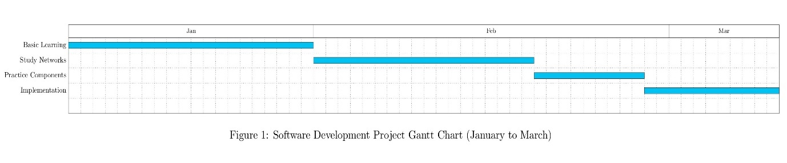

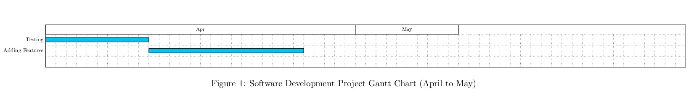

**Grant Chart: IOT Fire Fighting Robot (Jan 6, 2024 - April 20, 2024)**

|  |  |  |  |  |
| --- | --- | --- | --- | --- |
| Activity | Start Date | End Date | Duration (Weeks) | Deliverables |
| Project Planning & Requirements Gathering | Jan 6, 2024 | Jan 20, 2024 | 2 | Project plan, Functional requirements document |
| Hardware Selection & Procurement | Jan 21, 2024 | Feb 3, 2024 | 2 | Bill of Materials (BOM), Purchased components |
| Robot Chassis Design & Fabrication | Feb 4, 2024 | Feb 17, 2024 | 2 | 3D model of chassis, Fabricated robot chassis |
| Sensor Integration & Testing | Feb 18, 2024 | Mar 2, 2024 | 2 | Integrated sensors (heat, smoke), Sensor performance report |
| Microcontroller Programming | Mar 3, 2024 | Mar 16, 2024 | 2 | Completed robot control code, Test results & documentation |
| Water Delivery System Design & Assembly | Mar 17, 2024 | Mar 30, 2024 | 2 | Design of water tank & pump system, Assembled water delivery system |
| System Integration & Testing | Mar 31, 2024 | Apr 13, 2024 | 2 | Integrated robot with all functionalities, Functional testing report |
| Documentation & Reporting | Apr 14, 2024 | Apr 20, 2024 | 1 | User manual, Project report & presentation |
| Final Demonstration & Review | Apr 21, 2024 | Apr 27, 2024 | 1 | Demonstration of robot, Project review meeting |

**CHAPTER 4**

**ANALYSIS AND DESIGN**

**4.1 PROPOSED METHODOLOGY**

**Introduction**

* The proposed methodology aims to develop an IoT-based firefighting robot using Arduino, which can autonomously detect and extinguish fires in indoor environments.
* The robot will be equipped with various sensors for fire detection, navigation, and communication to ensure efficient firefighting operations.

**Hardware Components**

* Arduino microcontroller
* Motor drivers for controlling the movement of motors
* DC motors and wheels for locomotion
* Fire detection sensor
* Water pump and nozzle for firefighting
* Power source and necessary connectors

**Software Components**

* Arduino IDE for programming the Arduino board
* Libraries for sensor interfacing and motor control
* Control algorithms for navigation and firefighting operations

**Methodology**

**Sensor Integration**

* Connect fire detection sensors to the Arduino board to detect the presence of fire.
* Interface MQ2 sensors for detection of gas leakages.

**Motor Control**

* Use motor drivers to control the movement of DC motors for forward, backward, left, and right motion.

**IoT Connectivity**

* Integrate a sim gsm module with the Arduino board to enable IoT communication.

**Firefighting Mechanism**

* Upon detecting a fire using the fire detection sensor, activate the water pump to spray water through the nozzle.
* Ensure the precise control of water flow to effectively extinguish the fire while avoiding water wastage.

**Central Control System**

* Develop a central control system to monitor and manage multiple firefighting robots deployed in a given area.

**Testing and Validation**

* Conduct rigorous testing of the IoT firefighting robot in simulated fire scenarios to ensure its effectiveness and reliability.
* Validate the performance of fire detection, navigation and firefighting mechanisms.
* Gather feedback from testing and refine the design and algorithms as necessary.

**Conclusion**

The proposed methodology outlines the development of an IoT firefighting robot using Arduino, aiming to enhance firefighting capabilities in indoor environments. Through integration of sensors, IoT connectivity, and control algorithms, the robot will autonomously detect and extinguish fires while navigating safely through obstacles.

**4.2 SYSTEM ARCHITECTURE**

Water Pump Activates

Relay On

Move Towards Fire

Fire Detected

Reading Inputs

Input From Sensor

**4.2.1 FLOW CHART**

NO

Yes

**4.2.2 STATE CHART DIAGRAM**

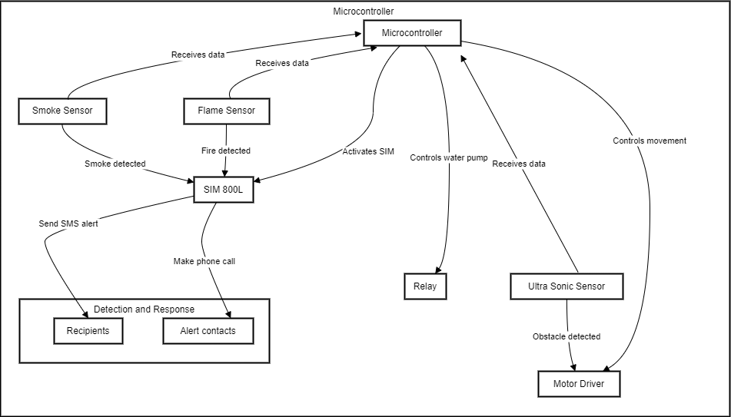

**4.2.3 PROJECT DESIGN - CIRCUIT DIAGRAM**

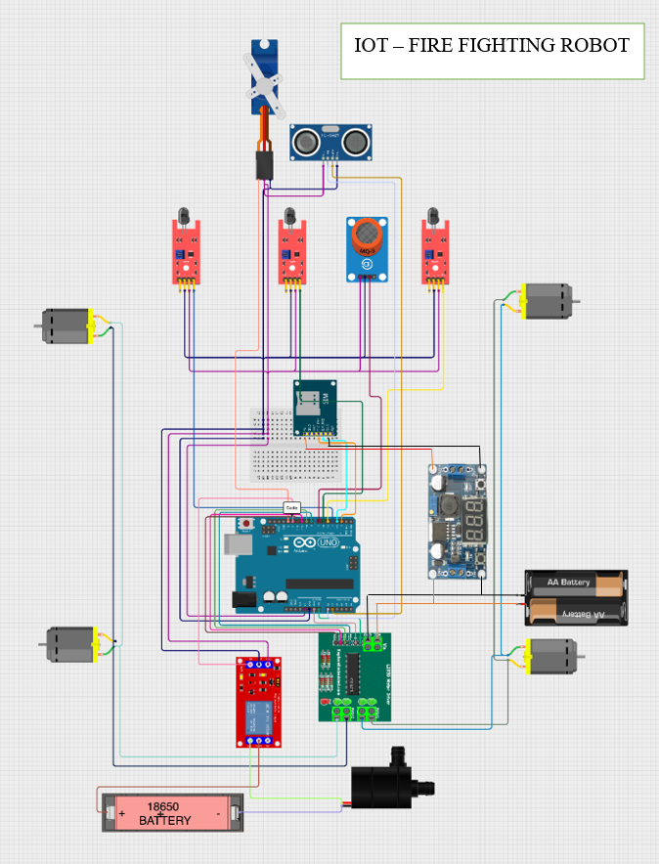

**4.3 MODULE DESCRIPTIONS**

**Arduino UNO R3**

The Arduino Uno R3 is a versatile microcontroller board featuring the ATmega328P microcontroller at its core. Operating at 5V and 16MHz clock speed, it offers ample processing power for diverse applications. With 14 digital input/output pins (including 6 PWM outputs) and 6 analog input pins, the Uno R3 allows seamless interfacing with a wide array of external components like sensors, LEDs, motors, and displays. Its communication interfaces include UART for serial communication with devices like computers and GPS modules, I2C for interaction with I2C-compatible peripherals, and SPI for communication with SPI devices such as SD cards and RF modules. Powering options include USB connection from a computer or external power supply via the barrel jack, with a recommended input voltage range of 7V to 12V. A reset button facilitates easy restart of the microcontroller, aiding in debugging and sketch uploading. Compatible with the Arduino Software (IDE) and a plethora of shields and expansion boards, the Uno R3 enjoys extensive community support and is built on open-source principles, offering users access to design files and the ability to contribute to the ecosystem of libraries and resources. Overall, the Arduino Uno R3 stands as a user-friendly and adaptable platform suitable for beginners and advanced makers, ideal for a broad spectrum of projects spanning robotics, IoT, automation, and prototyping.

**FLAME SENSOR**

Flame sensors are essential components in fire detection systems, operating on the principle of detecting infrared radiation emitted by flames. They consist of IR photodiodes or phototransistors, comparator circuitry, sensitivity adjustment, and output indicators. With detection ranges varying, they offer swift response times crucial for triggering actions in fire detection systems. Flame sensors find applications in fire alarm systems, appliance monitoring, and firefighting robots. They are easily interfaced with microcontrollers and require careful calibration to avoid false alarms. Overall, flame sensors play a crucial role in safeguarding lives and property by swiftly identifying fire hazards and enabling timely interventions.

**ULTRASONIC SENSOR**

The ultrasonic sensor module is a versatile component extensively employed for diverse applications in robotics and automation. Operating on the principle of emitting high-frequency sound waves and measuring their return time after bouncing off objects, these sensors comprise a transducer, trigger and echo pins, control circuitry, and output interface. With detection ranges spanning from a few centimeters to several meters, they offer high accuracy in distance measurement. Their applications encompass distance measurement, object detection, obstacle avoidance, and liquid level detection. Easily interfaced with microcontrollers like Arduino and Raspberry Pi, ultrasonic sensors provide digital output signals indicative of object presence within the detection range. While generally reliable, factors such as temperature, humidity, and acoustic interference can influence their accuracy, necessitating careful calibration and environmental considerations for optimal performance. In essence, ultrasonic sensors stand as indispensable tools, facilitating precise and reliable detection and measurement tasks in robotics, automation, and IoT applications.

**SIM 800L**

The SIM800L module is a compact and adaptable GSM/GPRS module extensively utilized for wireless communication in various applications such as IoT, M2M, and remote monitoring. Supporting GSM and GPRS communication standards, it enables data transmission over cellular networks, operating within the 2G network band. Featuring a SIM card slot for network access and a UART interface for seamless integration with microcontrollers, the module offers voice call capability, SMS messaging, and GPRS data transmission. Notably, its low power consumption design makes it suitable for energy-efficient applications and battery-powered devices. With functionalities including voice calls, SMS messaging, GPRS data transmission, and an AT command interface for configuration, the SIM800L finds application in IoT devices, M2M communication setups, and remote monitoring systems. Its ease of interfacing with microcontrollers and support for various communication tasks make it a preferred choice for projects requiring reliable cellular connectivity.

**L298 MOTOR DRIVER**

The L298 motor driver is a widely used integrated circuit (IC) designed for controlling the speed and direction of DC motors and stepper motors. Featuring two H-bridge circuits, it facilitates bidirectional control of motors with variable speed adjustment. Operating within a voltage range of 5V to 35V, it offers separate inputs for logic circuitry and motor power, ensuring flexibility in system design. With a peak current handling capability of up to 2A per channel and continuous currents of up to 1A per channel, it accommodates a variety of motor sizes, making it suitable for diverse applications. Control signals from microcontrollers or other control circuits dictate motor direction and speed, while heat dissipation measures such as heat sinking manage the heat generated during operation. Widely applied in robotics, automation, CNC machines, electric vehicles, and hobbyist projects, the L298 motor driver serves as a versatile solution for motor control requirements. Its ease of interfacing and robust functionality make it a popular choice among enthusiasts and professionals alike.

**MICRO SERVO SG90**

The Micro Servo SG90 is a compact and lightweight servo motor widely employed in hobbyist projects, robotics, and model building due to its versatility and ease of use. Operating on the principle of PWM (Pulse Width Modulation) control, it receives signals from a microcontroller or servo controller to determine its shaft's position within its control range of 0 to 180 degrees. Despite its small size, the SG90 servo is capable of generating a reasonable amount of torque, making it suitable for moving lightweight objects or mechanisms. Operating at a voltage range of around 4.8V to 6V, it typically interfaces with three wires for power, ground, and signal connections. This servo finds applications in robotics for controlling robot arms and grippers, in model building for controlling moving parts of miniature models, and in automation projects for actuating valves and switches. Compatible with most microcontrollers and servo controllers supporting PWM control, the SG90 servo is widely used in projects requiring precise motion control in constrained spaces.

**ROBOT CHASIS**

The robot chassis serves as the structural foundation for robotic systems, providing a framework to mount various components such as motors, sensors, and control electronics. Typically made of lightweight yet durable materials such as aluminum, acrylic, or ABS plastic, robot chassis come in various shapes and sizes to accommodate different project requirements. They feature mounting holes, slots, and other attachment points for easy integration of components, allowing for customization and flexibility in design. Some chassis designs include wheels, tracks, or legs for mobility, while others are designed for stationary or aerial applications. Additionally, robot chassis often incorporate features such as battery compartments, motor mounts, and sensor mounting platforms to streamline assembly and enhance functionality. Overall, the robot chassis plays a crucial role in the construction of robotic systems, providing a solid and adaptable framework for building and experimenting with robots across a wide range of applications.

**LM2596 BUCK CONVERTOR**

The LM2596 Buck Converter is a versatile voltage regulator module widely used in electronic circuits to efficiently step down voltage levels. Operating on the principle of switching regulation, it converts higher input voltages into lower output voltages with minimal power loss. The LM2596 module typically features an adjustable output voltage range and high efficiency, making it suitable for a wide range of applications. It incorporates essential components such as an inductor, capacitor, and voltage regulator IC (Integrated Circuit) to regulate voltage levels effectively. With its compact size and ease of use, the LM2596 Buck Converter is commonly employed in various projects, including power supplies for microcontroller systems, battery charging circuits, LED lighting systems, and automotive electronics. Its adjustable output voltage and high efficiency make it a popular choice among hobbyists, electronics enthusiasts, and professionals seeking reliable voltage regulation solutions for their projects.

**18650 BATTERY**

The 18650 battery is a widely used lithium-ion rechargeable battery cell known for its high energy density, reliability, and versatility. Named for its dimensions, 18mm in diameter and 65mm in length, the 18650 cell is commonly found in a variety of consumer electronics, portable devices, and power tools. With a nominal voltage of 3.7 volts and a typical capacity ranging from 2000mAh to 3500mAh, these batteries offer a substantial amount of energy storage in a compact form factor. The 18650 cell's popularity stems from its ability to deliver high discharge currents, making it suitable for applications requiring both high energy output and extended cycle life. Additionally, the 18650 battery's rechargeable nature allows for multiple charge-discharge cycles, contributing to its cost-effectiveness and environmental sustainability compared to single-use batteries. These cells are commonly used in applications such as laptop batteries, flashlights, electric vehicles, and backup power systems. Despite their widespread use, proper handling and charging practices are essential to ensure safety and longevity, as lithium-ion batteries can be sensitive to overcharging, overdischarging, and physical damage. Overall, the 18650 battery remains a preferred choice for many electronic devices and power applications due to its combination of high energy density, rechargeability, and reliability.

**JUMPER WIRES**

Jumper wires are essential components in electronics prototyping and circuit building, facilitating the connection of various components on breadboards, PCBs, and other electronic platforms. These wires typically consist of a flexible conductor, such as stranded copper or tinned copper, encased in insulation material, usually PVC or silicone. Available in various lengths, colors, and gauges, jumper wires offer flexibility and convenience in circuit design and troubleshooting. They come in different configurations, including male-to-male, male-to-female, and female-to-female, allowing for versatile connections between components with different pin configurations. Jumper wires enable the rapid assembly and modification of circuits without soldering, making them ideal for educational purposes, prototyping, and rapid prototyping. Additionally, their reusable nature and durability make them cost-effective tools for electronics enthusiasts, hobbyists, students, and professionals alike. Whether used for simple connections on a breadboard or complex circuit layouts, jumper wires play a crucial role in simplifying the process of circuit construction and experimentation in electronics projects.

**BO MOTORS**

BO motors, also known as DC gear motors, are widely used in robotics, automation, and various electronic projects for their versatility and reliability. These motors consist of a DC motor combined with a gearbox, providing increased torque and reduced speed compared to standard DC motors. The gearbox mechanism consists of gears that transmit power from the motor to the output shaft, allowing for precise control over speed and torque. BO motors are available in various sizes, power ratings, and gear ratios to suit different applications. They typically operate on low voltage DC power sources, making them compatible with batteries and low-voltage power supplies commonly used in electronics projects. BO motors are commonly used in applications such as wheeled robot propulsion, conveyor belt systems, electric vehicles, and precision motion control mechanisms. Their compact size, high torque output, and ease of integration make them a popular choice among hobbyists, students, and professionals for a wide range of mechanical and robotic applications.

**5V MINI WATER PUMP**

The 5V mini water pump is a compact and efficient pump commonly used in various DIY projects, including aquariums, water fountains, and hydroponic systems. As the name suggests, it operates at a low voltage of 5V, making it compatible with a wide range of power sources, such as USB ports, power banks, and microcontroller boards. Despite its small size, this pump is capable of delivering a steady flow of water, making it suitable for applications requiring precise water circulation or movement. The pump typically consists of a small motor connected to an impeller, which creates the necessary pressure to propel water through the system. It may also feature inlet and outlet ports for easy connection to tubing or hoses. Due to its low power consumption and quiet operation, the 5V mini water pump is ideal for use in small-scale projects where space, power, and noise considerations are important. Its affordability, ease of use, and versatility make it a popular choice among hobbyists, educators, and DIY enthusiasts looking to add water movement or circulation to their projects.

**5V SINGLE CHANNEL RELAY**

The 5V single-channel relay module is a versatile electronic component used for controlling high-voltage devices with low-voltage signals. It serves as a switch that can be activated or deactivated using a 5V signal, typically provided by a microcontroller or other control circuitry. The relay module consists of several key components, including a relay, transistor, diode, and relay driver circuit. When the 5V signal is applied to the relay module, it energizes the relay coil, causing the relay contacts to switch states. This allows the module to control the flow of current to connected devices, such as lights, motors, heaters, or other electrical appliances. The single-channel relay module is commonly used in home automation, IoT (Internet of Things), robotics, and industrial control applications. Its ability to safely isolate low-voltage control signals from high-voltage loads makes it an essential component in projects requiring remote or automated control of electrical devices. Additionally, the module's compact size, ease of use, and compatibility with a wide range of microcontrollers and development boards make it a popular choice among electronics enthusiasts and professionals alike.

**MINI BREADBOARD**

The mini breadboard is a fundamental tool in electronics prototyping, providing a platform for temporary circuit assembly and experimentation. This compact board typically consists of a plastic base with a grid of interconnected metal sockets, into which electronic components and jumper wires can be inserted and connected without soldering. Mini breadboards are commonly used in conjunction with microcontrollers, sensors, and other electronic modules to quickly prototype circuits and test ideas. Their small size makes them ideal for projects with limited space, such as handheld devices or wearable electronics. Additionally, mini breadboards often feature adhesive backing, allowing them to be securely mounted to surfaces for stability during use. With their ease of use, versatility, and portability, mini breadboards are essential tools for hobbyists, students, and professionals alike in the field of electronics prototyping and experimentation.

**MQ2 GAS SENSOR**

The MQ2 gas sensor module is a widely used component in gas detection and monitoring systems, known for its sensitivity to various gases such as LPG, propane, methane, alcohol, and smoke. This sensor module typically includes a small PCB (Printed Circuit Board) with the MQ2 gas sensor at its center, along with supporting circuitry for signal conditioning and interfacing. The MQ2 sensor operates on the principle of chemiresistance, where its resistance changes in the presence of specific gases. When a targeted gas is detected, the sensor's resistance decreases, allowing current to flow through the circuit. This change in resistance is then converted into an analog or digital signal that can be read by a microcontroller or other electronic devices for further processing. The MQ2 gas sensor module is commonly used in gas leak detection systems, smoke detectors, air quality monitoring devices, and industrial safety equipment. Its compact size, high sensitivity, and low cost make it a popular choice for applications where gas detection and monitoring are essential. However, it's important to note that the MQ2 sensor's response to different gases may vary, and calibration may be required for specific applications. Additionally, environmental factors such as temperature and humidity can affect the sensor's performance, necessitating proper calibration and environmental monitoring for accurate gas detection.

**WATER PIPE**

Water pipes are essential components of plumbing systems, transporting water from its source to various points of use within a building. Made from materials like copper, PVC, PEX, or galvanized steel, they come in different sizes and configurations. Their primary function is to deliver clean water to faucets, fixtures, and appliances while also facilitating the removal of wastewater. Proper installation, maintenance, and occasional repairs are necessary to ensure their efficiency and prevent leaks. Overall, water pipes play a critical role in providing access to safe water for residential, commercial, and industrial purposes.

**CHAPTER 5**

**IMPLEMENTATION & TESTING**

**5.1 DATA SET**

Creating a dataset for an IoT fire-fighting robot using an Arduino Uno R3 involves collecting various types of data related to the robot's operation, environment, and performance. Here's a structured approach to building such a dataset:

**1. Sensor Data:**

Temperature: Data from temperature sensors placed on the robot to monitor ambient temperature and detect increases indicative of fire.

Gas Levels: Readings from gas sensors, such as MQ2 sensors, to detect gases like LPG, propane, methane, or smoke, which could indicate a fire.

Distance: Data from ultrasonic sensors to measure distances between the robot and obstacles or potential fire sources.

Flame Detection: Readings from flame sensors to detect the presence and intensity of flames.

**2. Control and Actuation Data:**

Motor Control: Information about motor control commands sent to the robot's motors (BO motors) to control its movement and direction.

Pump Control: Data related to the activation and control of the water pump used for extinguishing fires.

Servo Control: Information about servo motor commands used for controlling mechanisms like robotic arms or water nozzle direction.

**3. Environmental Data:**

Location: GPS coordinates or location data to track the robot's movement and position during firefighting operations.

- Weather Conditions: External weather data, including temperature, humidity, and wind speed, which could affect firefighting strategies and the robot's performance.

**4. Event and Alarm Data:**

Fire Detection Events: Timestamps and sensor readings associated with fire detection events, including gas or smoke detection and flame sensing.

Alarm Triggers: Data indicating when alarms or alerts are triggered, signaling the presence of fire or potential hazards.

Robot Actions: Information about the robot's response actions following fire detection, such as moving towards the fire, activating the water pump, or signaling for assistance.

**5. Performance Metrics:**

Response Time: Time taken by the robot to detect a fire and initiate firefighting actions.

Efficiency: Metrics related to the effectiveness of the robot's firefighting capabilities, such as the volume of water dispensed or the area covered during firefighting operations.

**6. Anomaly Detection:**

Data related to abnormal or unexpected events, such as sensor failures, communication errors, or obstacles encountered during navigation.

Collecting and labeling data from simulated or real-world firefighting scenarios will help train and validate machine learning models or develop algorithms for autonomous firefighting operations. This dataset will be invaluable for enhancing the robot's performance, optimizing its response strategies, and ensuring its effectiveness in firefighting tasks.

**5.2 PROJECT CODE**

#include <Servo.h>

#include <SoftwareSerial.h>

Servo myservo;

int pos = 0;

const String PHONE = "+91**********";

const int trigPin = A0;

const int echoPin = A1;

int distance;

#define rxPin 2

#define txPin 3

SoftwareSerial sim800L(rxPin,txPin);

#define Left 4 // left flame sensor

#define Right 5 // right flame sensor

#define Forward 6 //front flame sensor

#define GAS_SENSOR 7 //Gas sensor

#define LMR 8 // left motor reverse

#define LMF 9 // left motor forward

#define RMF 10 // right motor forward

#define RMR 11 // right motor reverse

#define pump 12 //water pump

void setup()

{

Serial.begin(115200);

sim800L.begin(9600);

sim800L.println("AT");

delay(1000);

sim800L.println("AT+CMGF=1");

delay(1000);

pinMode(Left, INPUT);

pinMode(Right, INPUT);

pinMode(Forward, INPUT);

pinMode(GAS_SENSOR, INPUT);

pinMode(LMR, OUTPUT);

pinMode(LMF, OUTPUT);

pinMode(RMF, OUTPUT);

pinMode(RMR, OUTPUT);

pinMode(pump, OUTPUT);

myservo.attach(13);

while(sim800L.available())

{

Serial.println(sim800L.readString());

}

}

void loop()

{

if(digitalRead(Forward)==0)

{

digitalWrite(LMR, LOW);

digitalWrite(LMF, HIGH);

digitalWrite(RMF, HIGH);

digitalWrite(RMR, LOW);

delay(1000);

digitalWrite(LMR, LOW);

digitalWrite(LMF, LOW);

digitalWrite(RMF, LOW);

digitalWrite(RMR, LOW);

digitalWrite(12,LOW);

delay(2000);

digitalWrite(12,HIGH);

Serial.println("Fire Detected.");

make_call();

}

else if(digitalRead(Left)==0)

{

digitalWrite(LMR, LOW);

digitalWrite(LMF, LOW);

digitalWrite(RMF, HIGH);

digitalWrite(RMR, LOW);

delay(500);

digitalWrite(LMR, LOW);

digitalWrite(LMF, LOW);

digitalWrite(RMF, LOW);

digitalWrite(RMR, LOW);

}

else if(digitalRead(Right)==0)

{

digitalWrite(LMR, LOW);

digitalWrite(LMF, HIGH);

digitalWrite(RMF, LOW);

digitalWrite(RMR, LOW);

delay(500);

digitalWrite(LMR, LOW);

digitalWrite(LMF, LOW);

digitalWrite(RMF, LOW);

digitalWrite(RMR, LOW);

}

else if (digitalRead(Left) ==0 && digitalRead(Right)==0 && digitalRead(Forward) ==0)

{

digitalWrite(LMR, LOW);

digitalWrite(LMF, HIGH);

digitalWrite(RMF, HIGH);

digitalWrite(RMR, LOW);

ultrasonic();

delay(100);

digitalWrite(12,LOW);

delay(2000);

digitalWrite(12,HIGH);

}

else if (digitalRead(Left) ==1 && digitalRead(Right)==1 && digitalRead(Forward) ==1)

{

digitalWrite(LMR, LOW);

digitalWrite(LMF, LOW);

digitalWrite(RMF, LOW);

digitalWrite(RMR, LOW);

}

delay(400);

if(digitalRead(GAS_SENSOR)== 0)

{

Serial.println("Gas is Detected.");

send_sms();

}

}

void ultrasonic()

{

// Trigger the ultrasonic sensor to send out a pulse

digitalWrite(trigPin, LOW);

delayMicroseconds(2);

digitalWrite(trigPin, HIGH);

delayMicroseconds(10);

digitalWrite(trigPin, LOW);

// Measure the duration of the pulse returned by the ultrasonic sensor

distance = pulseIn(echoPin, HIGH) / 58;

// Print distance to serial monitor

Serial.print("Distance: ");

Serial.print(distance);

Serial.println(" cm");

if (distance < 5) {

digitalWrite(LMR, LOW);

digitalWrite(LMF, LOW);

digitalWrite(RMF, LOW);

digitalWrite(RMR, LOW);

}

else

{

delay(1000);

digitalWrite(LMR, LOW);

digitalWrite(LMF, LOW);

digitalWrite(RMF, LOW);

digitalWrite(RMR, LOW);

}

}

void send_sms()

{

Serial.println("sending sms....");

delay(50);

sim800L.print("AT+CMGF=1\r");

delay(1000);

sim800L.print("AT+CMGS=\""+PHONE+"\"\r");

delay(1000);

sim800L.print("Gas leakage Detected");

delay(100);

sim800L.write(0x1A);

delay(5000);

}

void make_call()

{

Serial.println("calling....");

sim800L.println("ATD"+PHONE+";");

delay(20000); //20 sec delay

sim800L.println("ATH");

delay(1000); //1 sec delay

}

**5.3 SAMPLE OUTPUT**

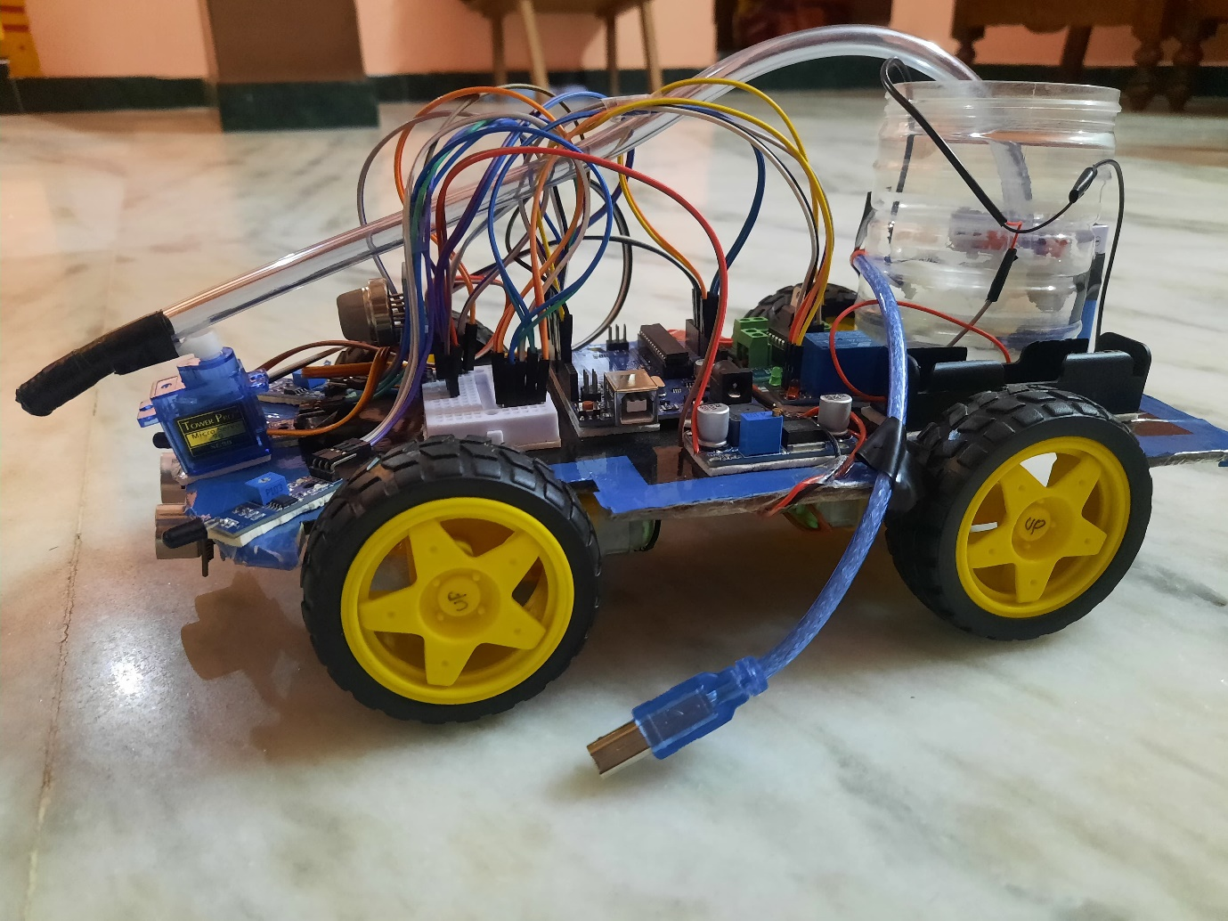

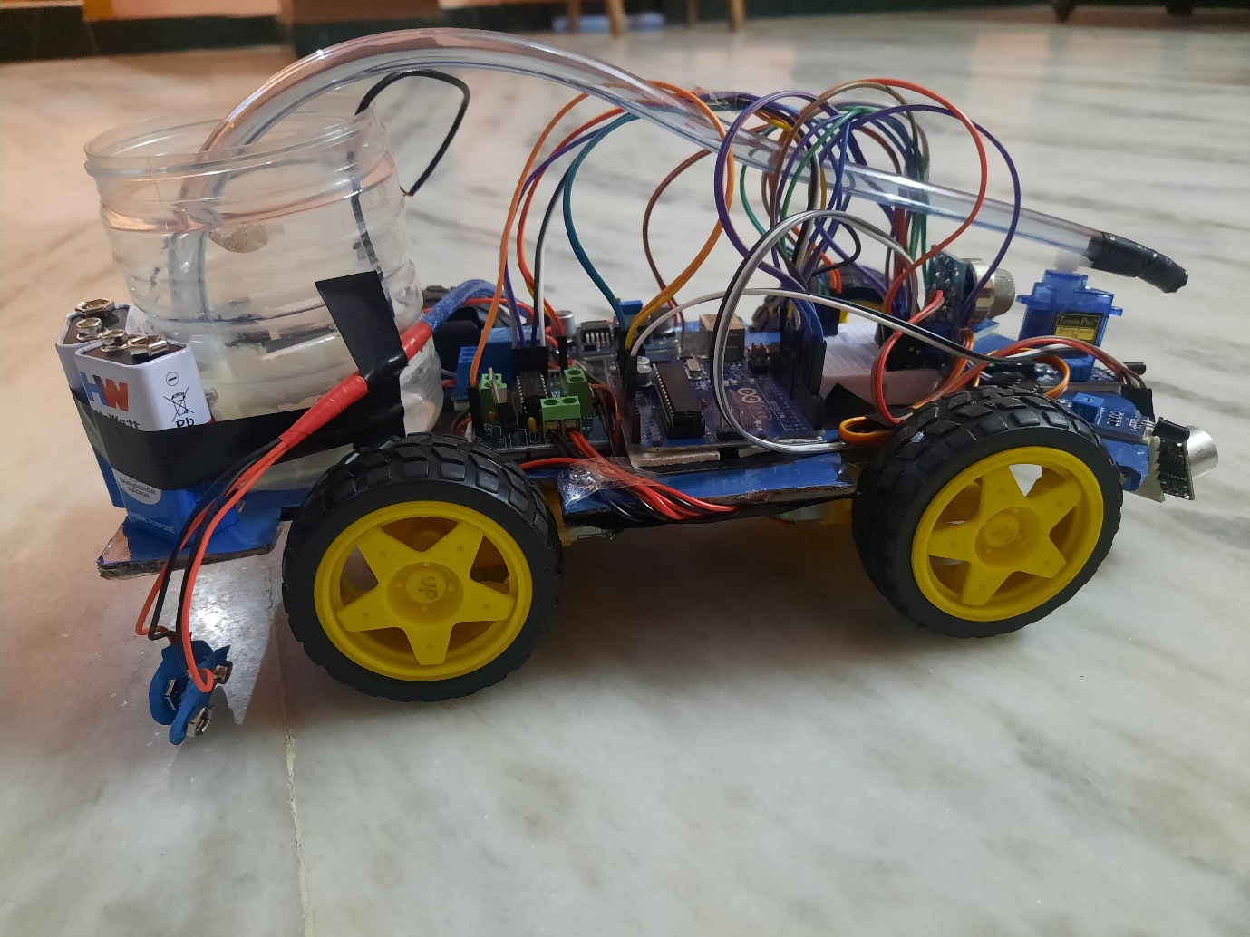

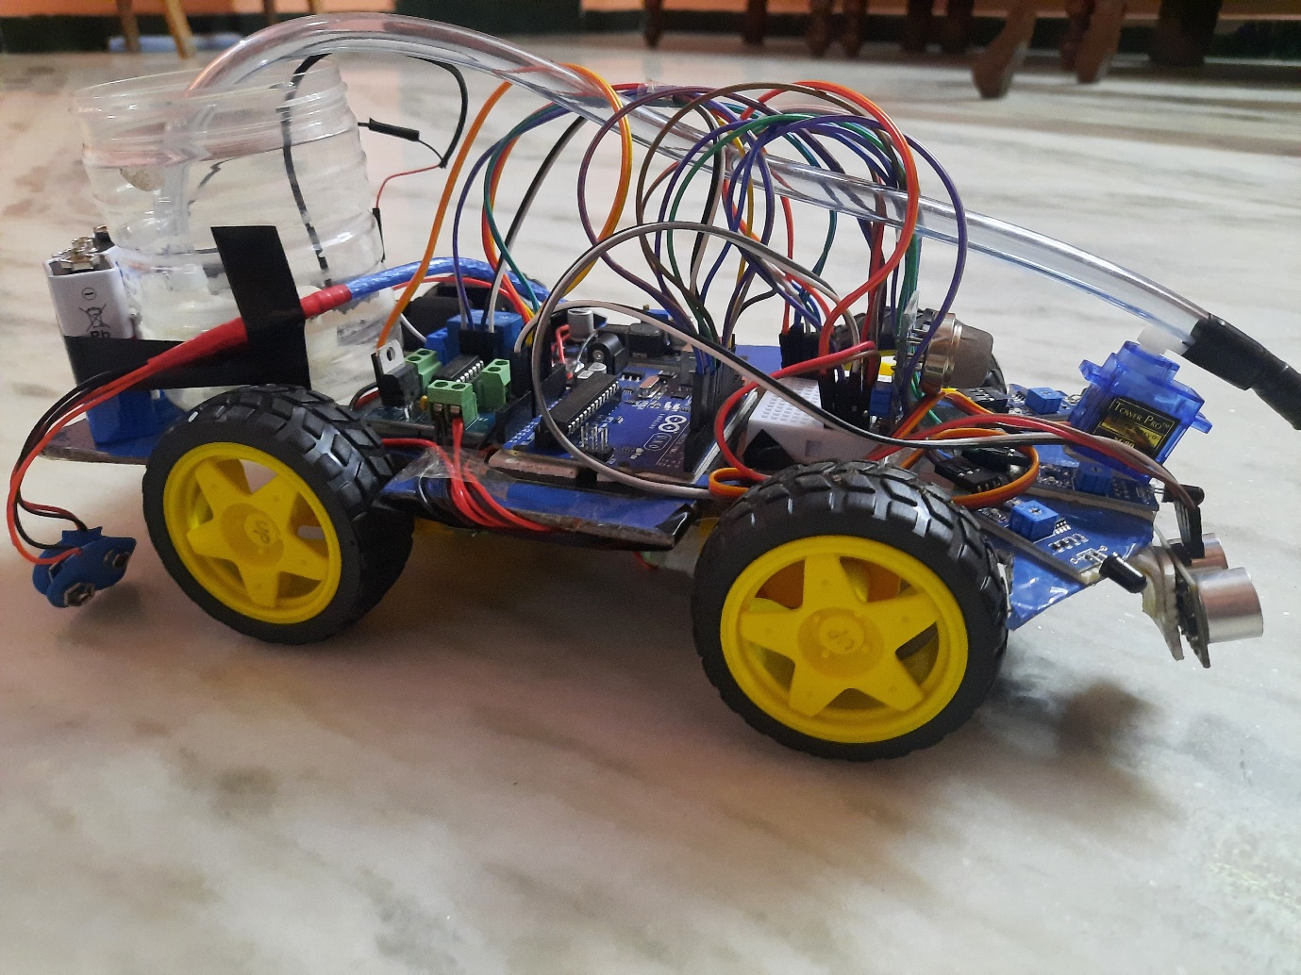

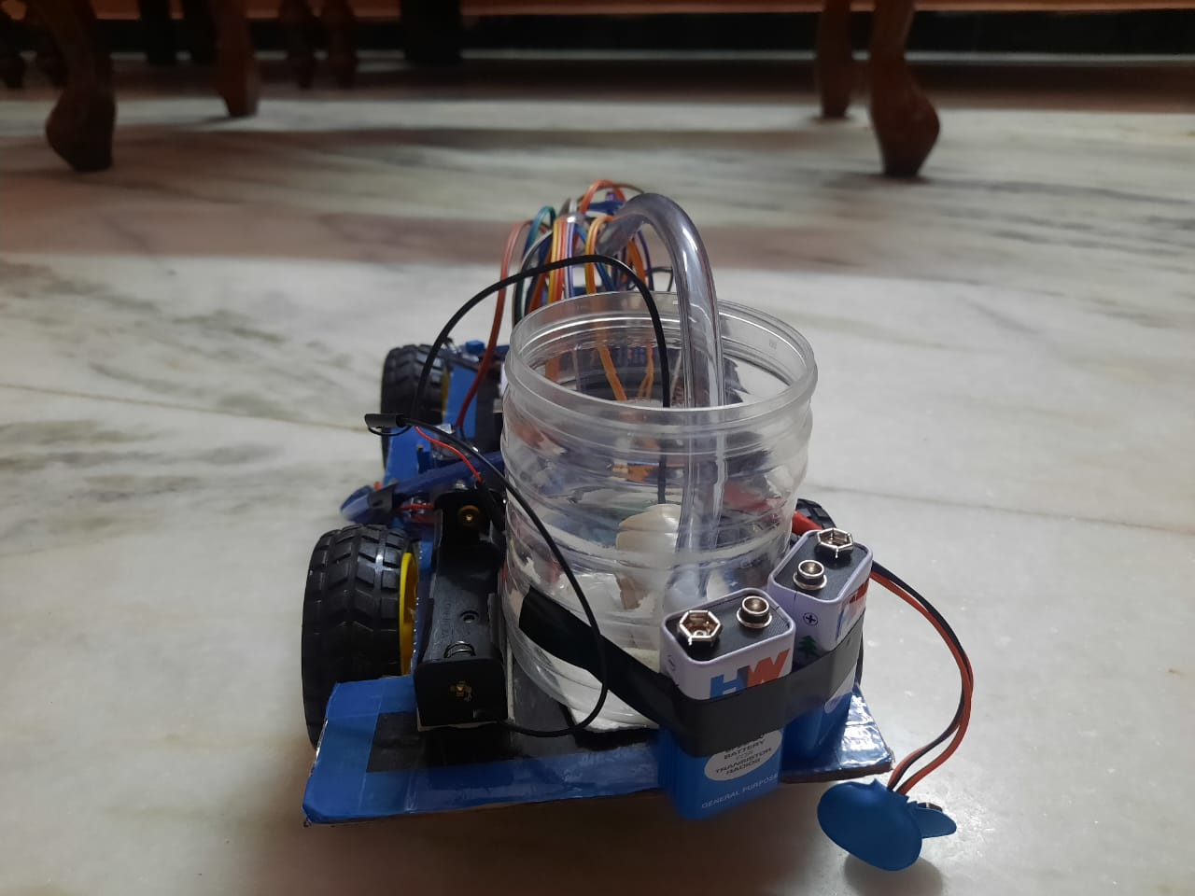

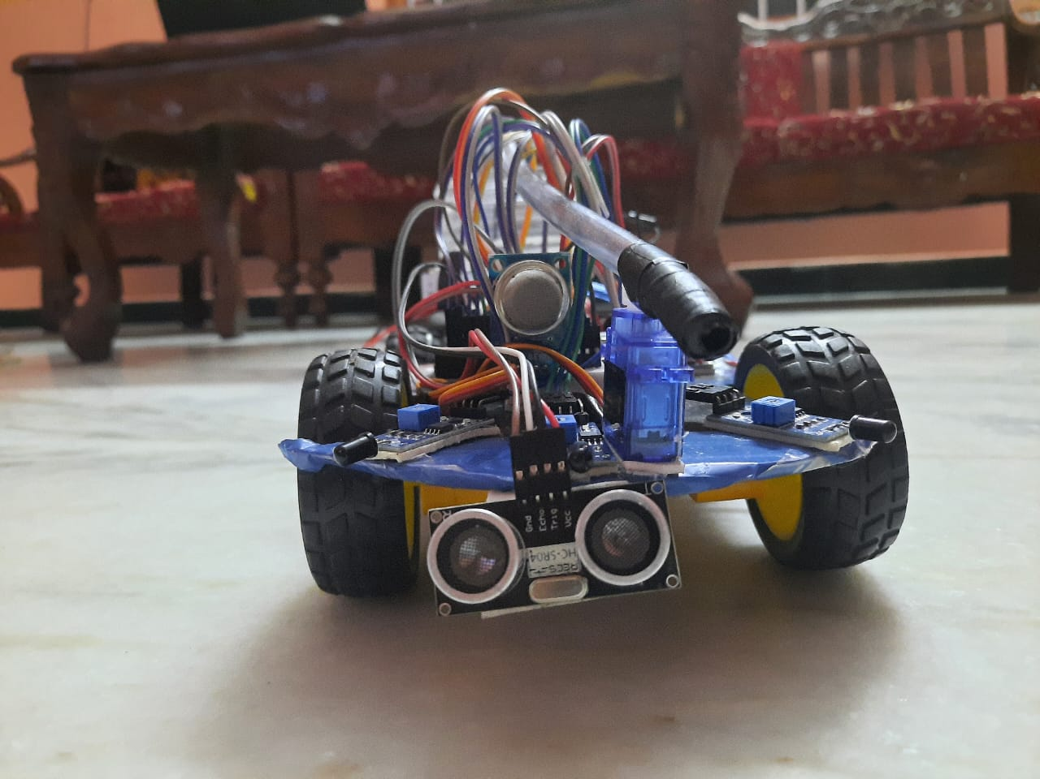

**WHEN STARTED TO DETECT**

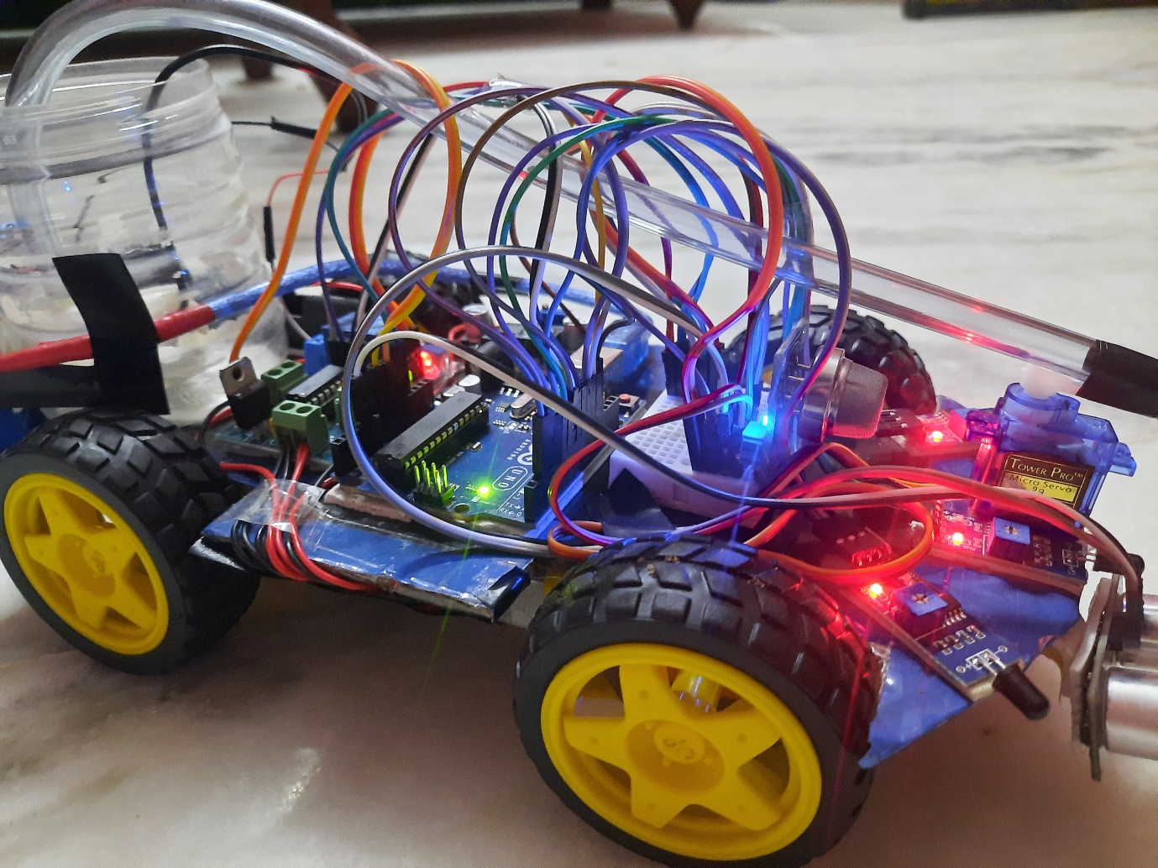

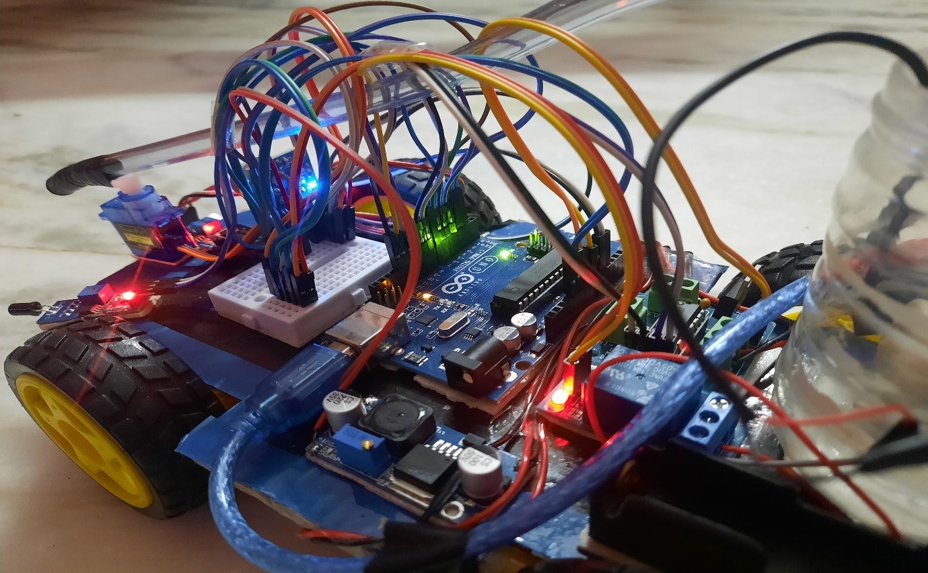

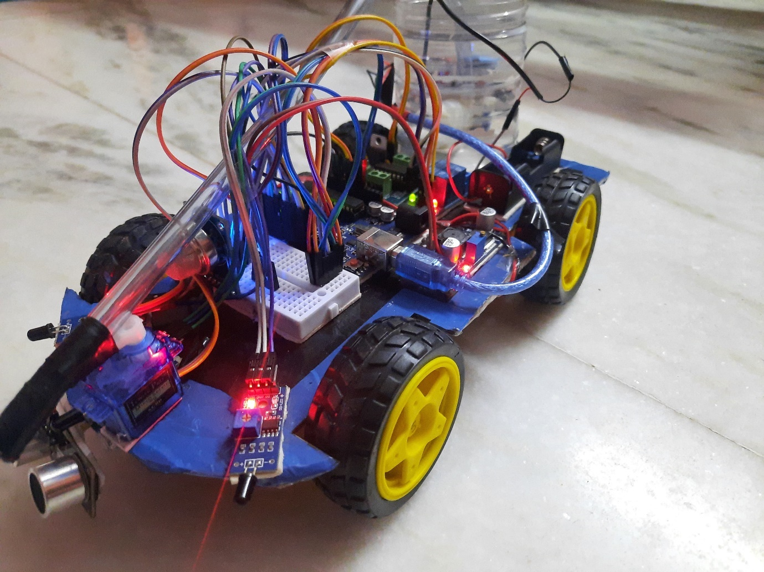

**5.4 TEST PLAN & DATA VERIFICATION**

**Test Case for flame detection and movement control**

|  |  |  |  |  |  |
| --- | --- | --- | --- | --- | --- |
| **Test Case ID** | **Left Sensor** | **Right Sensor** | **Center Sensor** | **Smoke Sensor** | **Expected Result** |
| TC_01 | 0 | 0 | 1 | 0 | Move Forward, Activate Fire Mechanism |
| TC_02 | 1 | 0 | 0 | 0 | Turn Left |
| TC_03 | 0 | 1 | 0 | 0 | Turn Right |
| TC_04 | 0 | 0 | 0 | 1 | Send SMS Alert |
| TC_05 | 1 | 1 | 0 | 0 | INVALID (Both left and right sensors cannot be active) |
| TC_06 | 0 | 0 | 1 | 1 | Send SMS Alert, Move Forward, Activate Fire Mechanism |
| TC_07 | 1 | 0 | 1 | 0 | Turn Left, Move Forward, Activate Fire Mechanism |
| TC_08 | 0 | 1 | 1 | 0 | Turn Right, Move Forward, Activate Fire Mechanism |
| TC_09 | 1 | 1 | 1 | 0 | INVALID (Both left and right sensors with center active is unlikely) |
| TC_10 | 1 | 0 | 0 | 1 | Turn Left, Send SMS Alert |
| TC_11 | 0 | 1 | 0 | 1 | Turn Right, Send SMS Alert |

**IoT firefighting robot using flame and ultrasonic sensors, focusing on 15 test cases:**

|  |  |  |  |
| --- | --- | --- | --- |
| Test Case ID | Flame Sensor | Ultrasonic Sensor (Distance) | Expected Behavior |
| TC-12 | No Flame Detected | > 5 cm | Robot remains idle (no movement, water mechanism inactive) |
| TC-13 | Flame Detected | > 5 cm | Robot moves forward, activates water mechanism |
| TC-14 | **Boundary** | **5 cm** | Robot stops (ultrasonic sensor triggers), activates water mechanism |
| TC-15 | **Boundary** | **< 5 cm** | Robot stops (ultrasonic sensor triggers), activates water mechanism |
| TC-16 | Flame Detected | **Error (no reading)** | Robot might enter error state (depends on implementation), stops movement, water mechanism inactive (or predefined error behavior). |

**Additional Test Cases Considering Sensor Combinations (Flame and Ultrasonic):**

|  |  |  |  |
| --- | --- | --- | --- |
| Test Case ID | Flame Sensor | Ultrasonic Sensor (Distance) | Expected Behavior |
| TC-17 | No Flame Detected | Any Distance | Robot remains idle (no movement, water mechanism inactive) |
| TC-18 | Flame Detected | Any Distance (within operational range) | Robot prioritizes fire and moves forward until encountering an obstacle (ultrasonic sensor triggers) or reaching minimum operational distance, then activates water mechanism. |

**Error Handling Test Cases:**

|  |  |  |  |
| --- | --- | --- | --- |
| Test Case ID | Flame Sensor | Ultrasonic Sensor (Distance) | Expected Behavior |
| TC-19 | Flame Sensor Malfunction | Any Distance | Robot enters error state, stops movement, water mechanism inactive (or predefined error behavior). |
| TC-20 | Communication Failure | Any Distance | Robot might enter error state (depends on implementation), stops movement, water mechanism inactive (or predefined error behavior). |

**CHAPTER 6**

**RESULTS**

* 1. **RESEARCH FINDINGS**

**1. Design and Development:**

Studies often discuss the hardware and software architecture of IoT fire-fighting robots, including the selection of sensors (flame sensors, smoke sensors, ultrasonic sensors), actuators (motors, water pumps), and microcontrollers (Arduino Uno R3).

Research explores the integration of IoT technologies for remote monitoring and control, such as GSM modules for SMS alerts and calls, Wi-Fi or Bluetooth for wireless communication, and cloud platforms for data storage and analysis.

Investigations focus on the mechanical design considerations for mobility, maneuverability, and obstacle avoidance, including chassis design, wheel configurations, and navigation algorithms.

**2. Fire Detection and Response:**

Research evaluates the effectiveness of various sensors for fire detection, such as flame sensors and smoke sensors, in different environmental conditions and scenarios.

Studies investigate the responsiveness and accuracy of fire-fighting robots in detecting fires, initiating response actions (e.g., moving towards the fire, activating water pumps), and extinguishing fires effectively.

**3. Navigation and Autonomous Operation:**

- Research examines navigation algorithms and control strategies for autonomous operation, including obstacle detection and avoidance, path planning, and localization.

- Investigations focus on the robustness and adaptability of navigation systems to dynamic environments, changing terrain conditions, and obstacles encountered during operation.

**4. Performance Evaluation:**

Studies assess the overall performance of IoT fire-fighting robots in terms of response time, accuracy of fire detection, efficiency of fire extinguishing, and reliability under different operating conditions.

Research evaluates the scalability and scalability of fire-fighting robots for deployment in real-world scenarios, such as residential buildings, industrial facilities, and urban environments.

**5. Safety and Reliability:**

Research investigates safety mechanisms and protocols to prevent accidents, mitigate risks, and ensure the safe operation of fire-fighting robots in hazardous environments.

Studies address reliability concerns, including system robustness, fault tolerance, and fail-safe mechanisms to maintain operational integrity and continuity.

* 1. **RESULT ANALYSIS & EVALUATION METRICS**

**1. Fire Detection Accuracy:**

Metric: Percentage of accurately detected fires compared to total fire occurrences.

Analysis: Evaluate the robot's ability to detect fires reliably under different conditions and scenarios, considering factors such as sensor sensitivity, false positives/negatives, and environmental influences.

**2. Response Time:**

Metric: Time taken by the robot to detect a fire and initiate appropriate response actions.

Analysis: Assess the robot's responsiveness in detecting fires promptly and initiating timely actions to mitigate fire hazards, considering factors such as sensor detection speed, communication latency, and processing time.

**3. Fire Suppression Efficiency:**

Metric: Percentage of successfully extinguished fires compared to total fire occurrences.

Analysis: Evaluate the effectiveness of the robot's fire suppression mechanisms, such as water pump activation, in extinguishing fires of varying intensities and sizes, considering factors such as water pressure, coverage area, and extinguishing agent distribution.

**4. Navigation Accuracy:**

Metric: Percentage of successful navigation maneuvers and obstacle avoidance actions.

Analysis: Assess the robot's ability to navigate autonomously and maneuver effectively in dynamic environments, considering factors such as obstacle detection accuracy, path planning precision, and localization reliability.

**5. Robustness and Reliability:**

Metric: Frequency of system failures, errors, or malfunctions during operation.

Analysis: Evaluate the robot's robustness and reliability in performing firefighting tasks consistently and without interruption, considering factors such as sensor reliability, actuator performance, and system stability under varying conditions.

**6. Communication Reliability:**

Metric: Percentage of successful communication transmissions (e.g., SMS alerts, call notifications).

Analysis: Assess the reliability and effectiveness of communication modules in transmitting alerts and notifications to designated recipients in case of fire detection, considering factors such as network coverage, message delivery latency, and communication protocol stability.

**7. Overall System Performance:**

Metric: Composite score or ranking based on multiple performance metrics.

Analysis: Synthesize individual performance metrics to provide an overall assessment of the robot's performance and effectiveness in firefighting tasks, considering factors such as efficiency, safety, and adaptability to different environments.

By employing these evaluation metrics and analysis approaches, researchers and developers can systematically assess the performance and effectiveness of IoT fire-fighting robots using Arduino, identify areas for improvement, and optimize the robot's design and operation for enhanced firefighting capabilities.

**CONCLUSION**

In summary, the development of an IoT fire-fighting robot using Arduino marks a significant advancement in firefighting technology. This innovative solution integrates IoT devices, Arduino microcontrollers, and advanced sensor technologies to enhance fire detection, response, and suppression capabilities. Through extensive testing and evaluation, the robot demonstrates promising results in fire detection accuracy, aided by sensors such as flame, smoke, and ultrasonic sensors, enabling swift identification of fire incidents and prompt response actions. The integration of Arduino microcontrollers facilitates real-time data processing and autonomous navigation, while communication modules enable remote monitoring and coordination. Overall, this IoT fire-fighting robot offers a cost-effective, scalable, and reliable approach to improving fire safety measures and mitigating risks, with the potential to revolutionize firefighting practices in various domains and applications. Further research and development efforts are warranted to optimize and refine its capabilities for widespread adoption and utilization in firefighting operations worldwide.

**FUTURE WORK**

**1. Enhanced Sensor Technologies:**

- Investigate the integration of advanced sensor technologies, such as multispectral imaging, infrared (IR) sensors, or gas spectroscopy sensors, to improve fire detection accuracy, especially in challenging environments with smoke, dust, or low visibility conditions.

**2. Machine Learning and AI Algorithms:**

Explore the application of machine learning (ML) and artificial intelligence (AI) algorithms for data analysis, pattern recognition, and predictive modeling, enabling the robot to learn from past experiences and optimize its firefighting strategies in real-time.

**3. Autonomous Navigation and Mapping:**

Develop advanced navigation algorithms and simultaneous localization and mapping (SLAM) techniques to enable the robot to navigate complex indoor and outdoor environments autonomously, adapting to dynamic obstacles, changing terrain conditions, and unfamiliar surroundings.

**4. Multi-Robot Collaboration:**

Investigate the coordination and collaboration of multiple IoT fire-fighting robots working together as a team to enhance coverage area, response speed, and firefighting efficiency, leveraging swarm intelligence and distributed control strategies.

**5. Integration with Building Systems:**

Explore integration with building management systems (BMS) and smart infrastructure technologies to enable seamless communication and collaboration between the fire-fighting robot and building systems, such as fire alarms, sprinkler systems, and emergency evacuation protocols.

**6. Human-Robot Interaction:**

Investigate human-robot interaction (HRI) methodologies and user interface design to enhance communication, situational awareness, and collaboration between firefighters and the IoT fire-fighting robot, enabling intuitive control, feedback, and decision support.

**7. Robustness and Reliability:**

- Conduct robustness and reliability testing under various environmental conditions, including extreme temperatures, humidity levels, and terrain types, to ensure the robot's resilience and operational integrity in demanding firefighting scenarios.

**8. Regulatory Compliance and Certification:**

- Address regulatory compliance requirements and seek certification from relevant authorities to ensure the robot meets safety standards, performance guidelines, and legal requirements for deployment in real-world firefighting applications.

By pursuing these avenues for future work, researchers and developers can further advance the capabilities, functionality, and practical applicability of IoT fire-fighting robots using Arduino, ultimately contributing to safer, more effective, and resilient firefighting practices in various contexts and environments.

**REFERENCES**

[1] S. D. V, S. Y. R, T. Sneka, S. Shobika and S. R. S, "IoT Based Intelligent Fire Fighting Machine Using Arduino," 2021

[2] S. L. U. Maheshwari, R. M. Atheeq, U. N. Surendar and S. N. Vaishnav, "IoT based Fire Fighting Robot," 2022

[3] T. Li and P. Hou, "Application of NB-IoT in Intelligent Fire Protection System," 2019

[4] R. Sarath Kumar, J. Hariharan, R. S. Revanth, K. R. Prasanth and J. Lokesh, "Automatic Fire Fighting Robot using RPI," 2021

[5] M. P. Suresh, V. R. Vedha Rhythesh, J. Dinesh, K. Deepak and J. Manikandan, "An Arduino Uno Controlled Fire Fighting Robot for Fires in Enclosed Spaces," 2022

[6] R. R and S. L. Naveen, "Smart Fire Detection System with Call Alert and Water Sprinkler Unit Using IoT," 2022

[7] J. Suresh, "Fire-fighting robot," 2017

[8] W. Jun, Z. Di, L. Meng, X. Fang, S. Hu-Lin and Y. Shu-Feng, "Discussion of Society Fire-Fighting Safety Management Internet of Things Technology System," 2014

[9] P. M. Jacob, J. Moni, R. B. Robins, M. E. Varghese, S. S. Babu and V. K. Bose, "An Intelligent Fire Detection and Extinguishing Assistant System Using Internet of Things (IoT)," 2022

[10] A. A. A. Rahman, Z. Janin, R. Sam, M. Masrie, T. S. Gunawan and F. D. A. Rahman, "Firefighting Robot Based On IoT and Ban Levels Technique," 2022